Section i – Vocabulary

- _______ Substance made up of atoms that all of the same number of protons
- _______ Substance made up of 2 or more elements that are chemically combined
- _______ Substance made up of 2 or more elements that are not chemically combined
- _______ Unevenly distributed mixture
- _______ Mixture with contents spread evenly throughout
- _______ The name given to electrons found in the outermost shell of an atom
- _______ The force that holds elements together in a compound
- _______ Process that involves the breaking and/or forming of bonds
- _______ Reaction where electrons get transferred between elements
- _______ Reaction where different elements share electrons
- _______ Covalent bonds usually form between 2 ____________
- _______ Ionic bonds usually form between a metal and a ________________
- _______ Occurs when a covalent bond forms but the electron isn’t shared equally
- _______ In a covalent bond, when the electron is shared equally
- _______ An atom’s affinity for an electron
- _______ The numerical prefix for the number 7
- _______ The numerical prefix for the number 9
- _______ The simplest version of a chemical formula
- _______ Substances formed by a chemical reaction
- _______ 2 or more substances combined to from a chemical compound
- _______ Reaction that produces oxygen and heat
- _______ A mixture that settles over time
- _______ Part of the solution that gets dissolved
- _______ Part of the solution that does the dissolving
25. _______ Determines acidity or basicity by testing the concentration of hydronium ions
A. Chemical reaction
- Product
- Metal(s)
- Mixture
- Element
- Electronegativity
- Solvent
- Combustion
- Homogeneous
- pH
- Compound
- Covalent
- Heterogeneous
- Nonpolar
- Chemical bond
- Solute
- Nona
- Valence
- Synthesis
- Hepta
- Nonmetal(s)
- Empirical
- Ionic
- Polar
- Suspension

Section ii – Matching

- _______ 3NaBr + 1H₃PO₄ 1Na₃PO₄ + 3HBr
- _______ 2PbSO₄ 2PbSO₃ + 1O₂
- _______ 1C₂H₄ + 3O₂ 2CO₂ + 2H₂O
- _______ 3Mg + 1Fe₂O₃ 2Fe + 3MgO
- _______ S₈ + 8O₂ 8SO₂
- Synthesis
- Decomposition
- Combustion
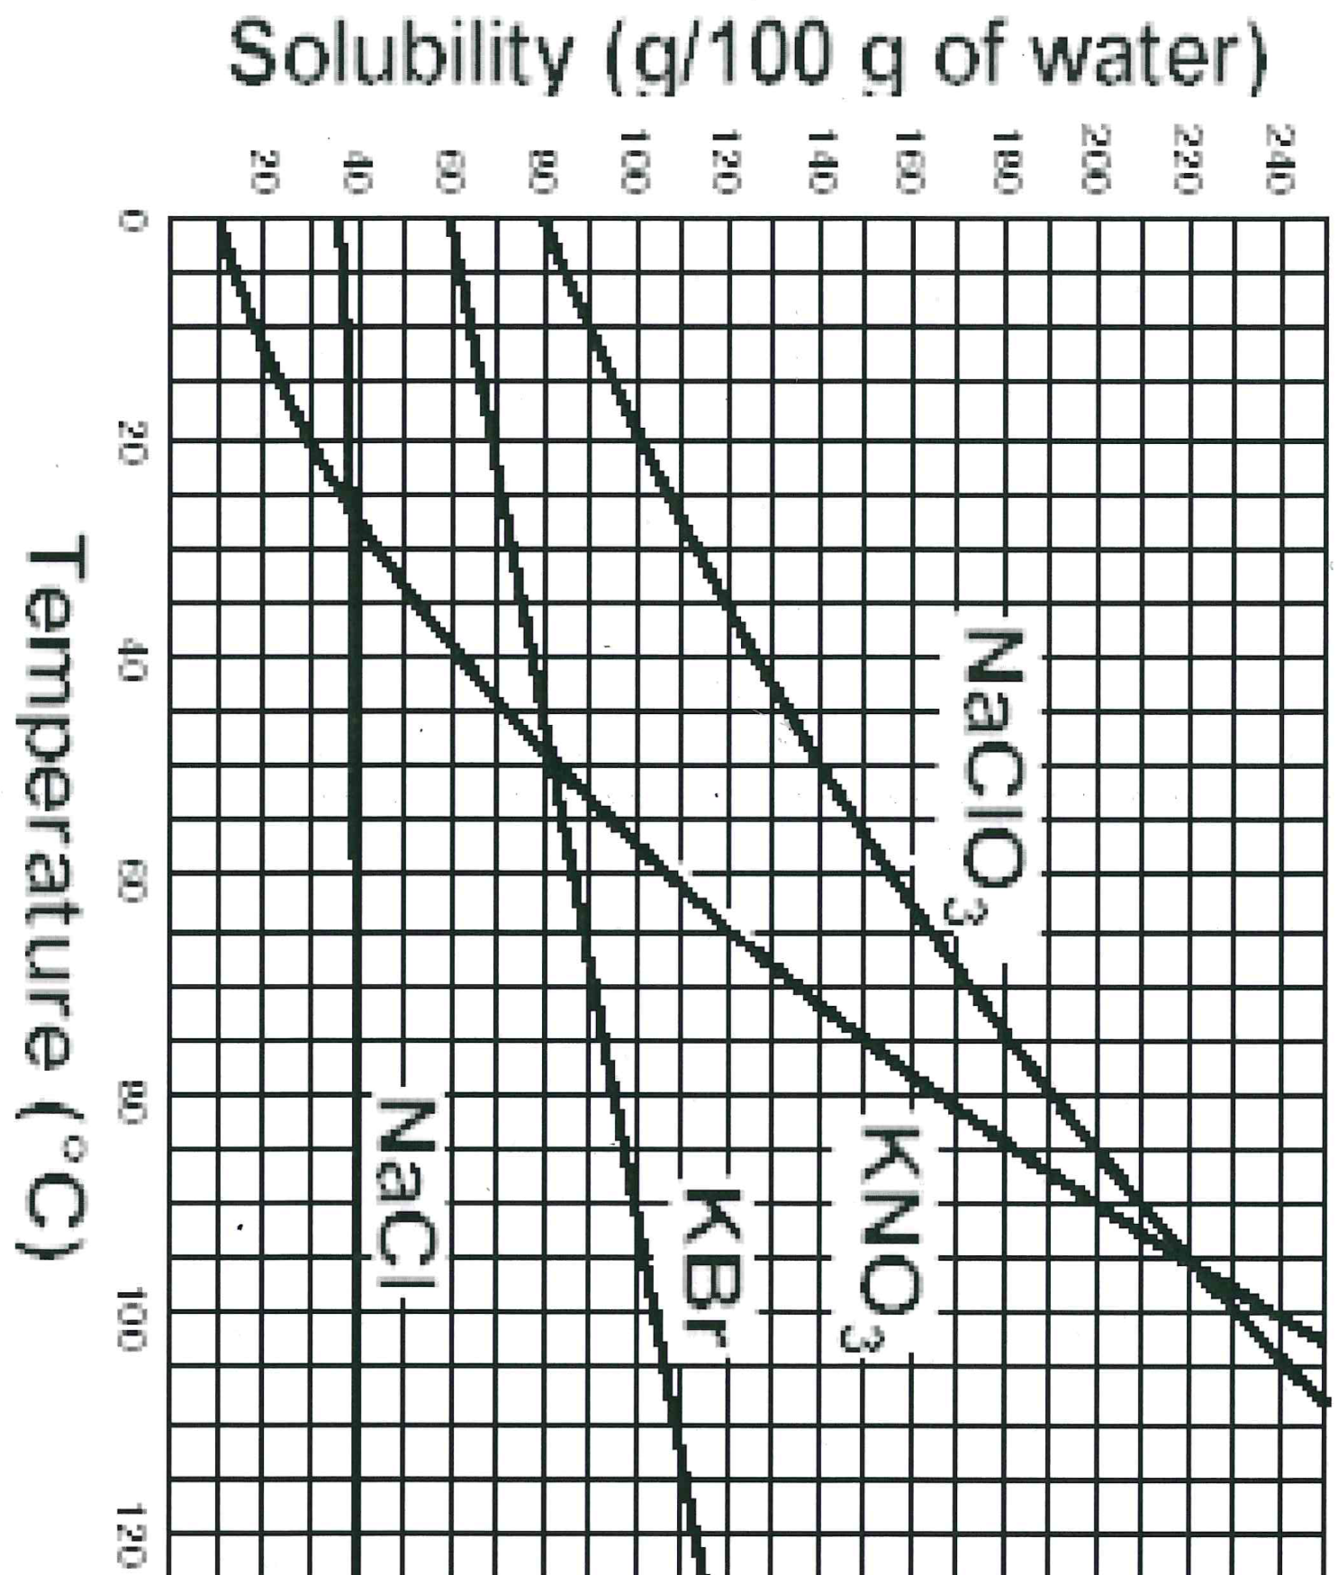
- Single replacement
- Double replacement

Section iii – Interpreting graphs (use graph to the right)
- What compound is most soluble at 40°C? _______
- What substance is most soluble at 100°C? _______
- Which substance solubility is affected the least by temperature change? _______
- What is the solubility of KBr at 70°C? _______
- At 65°C with 120g of KNO₃, the solution is said to be _____________________

Section iv – Identification: identify each of the following as ionic, covalent, polyatomic, or metallic.
- ____________________________________ NH₄⁺
- ____________________________________ Cu²⁺
- ____________________________________ NaCl
- ____________________________________ CH₃COOH
- ____________________________________ (PO₄)₃⁻
Section v – Balancing equations
- ______ P₄ + ______ Br₂ ______ PBr₃
- ______ Li₃PO₄ + ______ NaBr ______ Na₃PO₄ + ______ LiBr
- ______ HBr + ______ Mg(OH)₂ ______ MgBr₂ + ______ H₂O
- ______ AgNO₃ + ______ Li ______ LiNO₃ + ______ Ag
- ______ AlBr₃ + ______ K ______ KBr + ______ Al

Section v –Naming: name the following compounds and indicate whether they are covalent or ionic (circle one).
- Al(OH)₃ ionic covalent ________________________________________________________________________
- BaF₂ ionic covalent ________________________________________________________________________
- MgBr₂ ionic covalent ________________________________________________________________________
- N₂O₃ ionic covalent ________________________________________________________________________
- PF₃ ionic covalent ________________________________________________________________________
- PbO ionic covalent ________________________________________________________________________
- Fe₂O₃ ionic covalent ________________________________________________________________________
- NaCl ionic covalent ________________________________________________________________________
- Cu₂O ionic covalent ________________________________________________________________________
- P₄S₅ ionic covalent ________________________________________________________________________
Section vi –Short answer
- In your own words, define the term concentration.

- In your own words, define the term solubility and explain how we can represent this information graphically.

- Explain what properties make a solution a “strong” acid or base. What happens to these compounds when they are placed in water? Why is this information important?

- In the boxes provided, draw an example of a compound, homogeneous and heterogeneous mixture at the molecular level.

- Explain the reaction that occurs to form NaCl, commonly known as table salt. Include step-by-step description of each step.

