Section i – Vocabulary

- _______ Scientist who hypothesized that all atoms are exactly alike
- _______ Chemical compounds always contain the same elements in the same proportions
- _______ Created the “plum-pudding” model
- _______ Did the “gold foil experiment”, figured out mass was contained in center of atom
- _______ Small particles that come together to form an atom
- _______ The number of ____________ defines the element
- _______ _________________ atoms have no net charge
- _______ Occurs when an atom gains or loses an electron
- _______ Force that holds the protons and neutrons together in the center of the atom
- _______ Force that keeps the electrons orbiting around the center of the atom
- _______ _______________ is the total number of subatomic particles in the nucleus
- _______ Elements with same number of protons but different number of neutrons
- _______ Number of neutrons = mass number - _______________ number
- _______ Number of electrons that can be held in the “S” orbital
- _______ Number of electrons that can be held in the “D” orbital
- _______ The highest energy electron orbital (shell)
- _______ Another term for the “normal” energy state of an electron
- _______ A ___________ can “excite” an electron
- _______ Form of measurement used when measuring very small particles
- _______ Scientist that created the first Periodic Table
- _______ Created the Periodic Table we use today
- _______ The term given for rows on the periodic table
- _______ The term given for columns on the periodic table
- _______ The modern day Periodic Table is arranged by __________________
- _______ Electrons in the outermost shell
- _______ Formation of an ion
- _______ Group # of elements most likely to gain an electron
- _______ When unstable nuclei emit particles to become stable
- _______ Type of nuclear radiation with a +2 charge
- _______ Type of nuclear radiation that cannot ionize other particles
- _______ Type of nuclear radiation that is not made of matter
- _______ Type of nuclear radiation that can be either positively or negatively charged
- _______ Can be used to predict the age of fossils and rocks
- _______ Location on Periodic Table of elements with the smallest mass
- _______ Location on Periodic Table of elements with 8 valence electrons
A. Mass number
- Dalton
- Mendeleev
- Electric
- Protons
- Beta particle
- Ground
- Nuclear
- Valence
- Ionization
- Period
- Group
- Thomson
- Far right
- 10
- Gamma
- Isotopes
- Rutherford
- Mosely
- Neutron radiation
- F
- Ionization
- Dalton
- Mole
- 2
- Atomic number
- Photon
- Upper left
- Neutral
- Radiation
- Half life
- Subatomic
- Alpha particle
- Atomic
- 7

Section ii – Drawing
- On the diagram to the right, draw a Carbon atom

Section iii – Labeling (use diagram to the right)
- Electron
- Proton
- P Orbital
- S Orbital
- D Orbital

Section iv – Fill in the blank (use diagram to the right)
- # of protons: __________
- # of neutrons: __________
- # of electrons: __________
- # of valence electrons: __________

Section v – Fill in the blank
79
2
46. 47. 48. 49. 50.
__
______
__
______
O
oxygen
__
______
Ar
_________

238

Section v –Short response questions
- Which group of elements is most likely to donate (give up) an electron and why?

- Two molecules of Carbon can have different atomic masses. How can this occur?

- When an atom loses a neutron does it become a different element? Why or why not? EXPLAIN.

- How did Mendeleev organize the first periodic table? How is his method of organizing the periodic table different from the one we use today?

- Explain how you can use the periodic table to quickly identify the number of valence electrons. Why is the number of valence electrons so important when determining the properties of elements?

- In your own words, define the term ionization and explain how this can occur.

- List the 4 types of nuclear radiation and briefly describe each.

- Which type of nuclear radiation can travel the farthest and why?
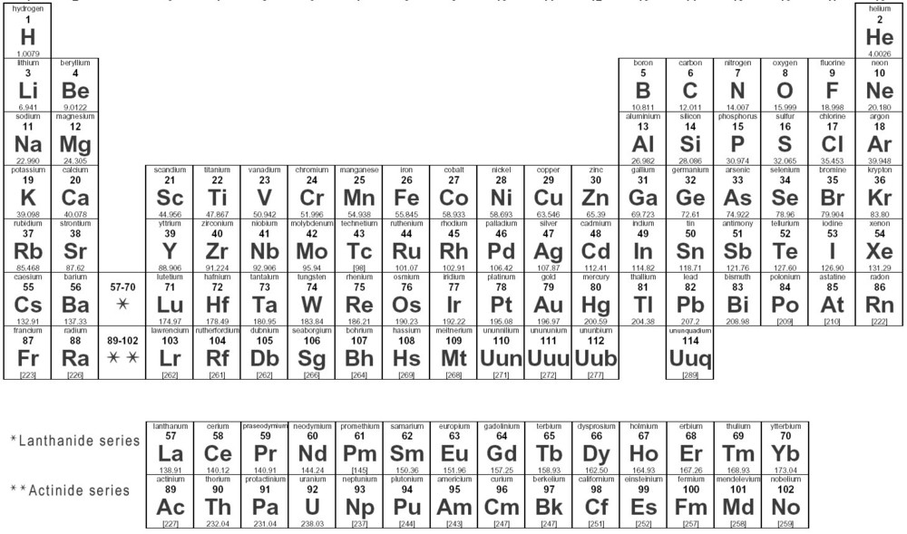
- On the periodic table to the right, color in and label elements that are: metals, nonmetals, and semiconductors. (Use a different color for each)

- Sodium has a half-life of 15 hours. How much Sodium-24 will remain in an 12 gram sample after 45 hours? Show all work

- Polonium-214 has a relatively short half-life of 164 seconds. How many seconds would it take for 8 grams of this isotope to decay to 3.25 grams? Show all work

- In 5.49 seconds, 1.2 grams of Argon-35 decay to leave only 0.15 grams. What is the half-life of Argon-35? Show all work

- Convert 200 grams of Ca to moles. Show all work

- Convert 8.25 moles of Fe to grams. Show all work

- How many protons does U-238 have? Show all work

