- Energy Name: ____________________________________________
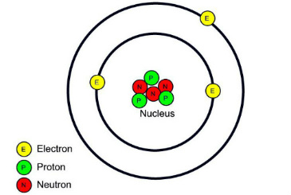
  - Two main forms:
    - _________________________
    - _________________________
  - Primary sources of energy:
    - Atomic/nuclear, Electromagnetic, Mechanical,
Electrical, Thermal, Gravitational
  - Energy is _________________________ and _________________________
- Nuclear Forces
  - Atomic structure
    - Nucleus- center of atom
      - _________________________ are positively charged particles
      - Neutrons are _________________________ or uncharged particles
    - Electrons
      - _________________________ charged particles
      - Constantly moving and orbiting the nucleus
  - Similar forces repel each other
    - Think of what happens when you put positive ends of magnets together
    - So how do all of those protons stay packed together in the nucleus?
      - _________________________ cause protons to attract one another over a small distance
  - In a _________________________ nucleus, the nuclear forces are stronger than the repulsive forces
  - If a nucleus has too many protons or neutrons it becomes unstable
    - An unstable nucleus will undergo _________________________
  - Nuclear decay is the release of particles from the nucleus of an atom in order to become more stable
    - As particles are released, _________________________ is also released
      - It takes energy to hold the nucleus together
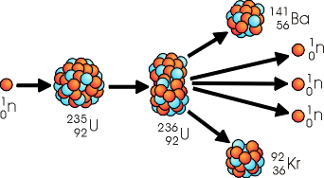
- Nuclear Fission
  - Nuclear _________________________ - splitting a large nuclei into smaller nuclei
    - This is done by firing _________________________ at the nucleus of a large atom
      - Destabilize the nuclear forces that hold together the nucleus
    - When the nucleus splits, _________________________ is released
  - _________________________ - when products of the initial reaction drive more reactions to occur
    - Can be controlled
    - Nuclear bomb makes use of uncontrolled chain reaction
  - Doesn’t require energy
  - __________________________________________________
  - Easier to control
- Nuclear Fusion
  - Nuclear _________________________ - combining small nuclei to form one larger nuclei
  - As nuclei form, large amounts of _________________________ are released
  - Requires a large amount of _________________________ to initiate the reaction
  - Nuclei are positively charged
  - Like forces repel, so energy is required to overcome those forces
  - __________________________________________________
  - In the sun, hydrogen atoms combine to form helium and release energy
  - Does not occur in chain reactions
  - Very _________________________ - produces too much energy
- Pros of Nuclear Power
  - Fission produces the _________________________ for the least amount of fuel
    - 1 lb of Uranium produces as much energy as 3,000,000 lbs of coal
  - Uranium is _________________________ in the Earth’s crust
  - Doesn’t produce any _________________________ as a byproduct
    - CO² is produced as the result of burning fossil fuels and is the cause of global warming
  - Doesn’t require storage (batteries) like wind and solar
  - _________________________ - takes up less land than wind or solar energy
- Cons of Nuclear Power
  - Accidents can lead to _________________________
  - Risk of terrorism and _________________________
  - Storage/disposal of _________________________
  - Radioactive waste has long half-life
  - High initial cost to build
  - Natural disasters can lead to contamination
    - Tsunami, earthquake, fire
  - Uranium’s half-life is 4.5 billion years
  - Products of Uranium and Plutonium fission have half-life of between 5 and 30 years
- Energy Transformations
  - Energy readily changes from one form to another
- Energy Transfer
  - Transfer of heat energy occurs in 3 ways:
    - _________________________
    - _________________________
    - _________________________
  - Recall from previous unit
    - Heat is the measure of average kinetic energy
    - More heat = more molecular movement = more energy
    - Solids have lowest energy, then liquids, then gases, with plasma having the most energy
- Conduction
    - _________________________- occurs between objects that are _________________________
    - If you hold a wire hanger over a fire it will eventually heat the wire
    - The temperature at the end over the fire is higher
    - Atoms at that end heat up and vibrate
    - That causes collisions between other atoms and transfers that energy down the wire
    - This causes the heat to travel the length of the wire
  - Can be _________________________or _________________________
- Convection
  - _________________________- occurs due to the movement of warm fluid
    - As a fluid is heated, it expands and becomes less dense
    - This causes it to rise above colder, more dense fluids
    - You can feel the heat from a campfire
  - _________________________ - the cycle of heated fluids expanding, rising, cooling off and then sinking
- Radiation
  - _________________________ - energy that is transferred as electromagnetic waves
    - You can feel the heat from a campfire
    - This is because fire emits energy in the form of _________________________
      - Infrared
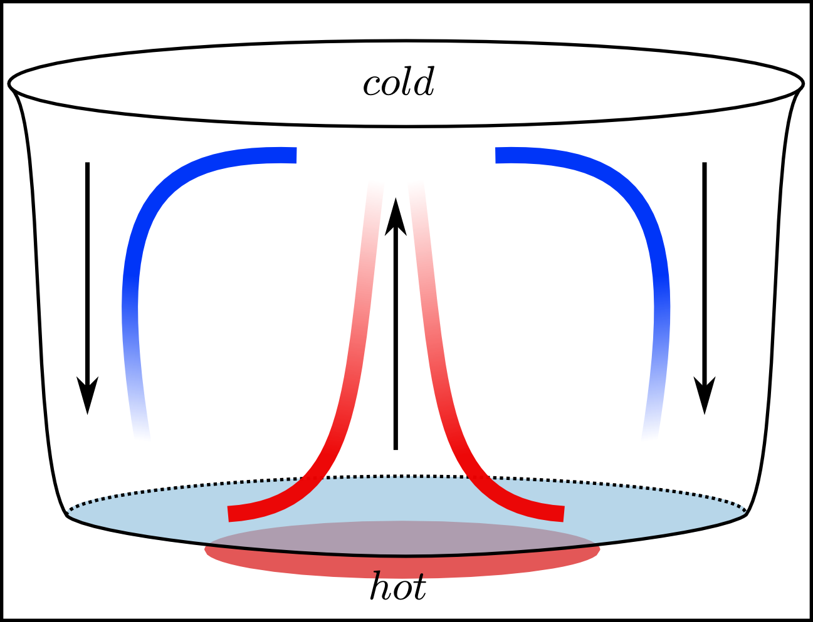
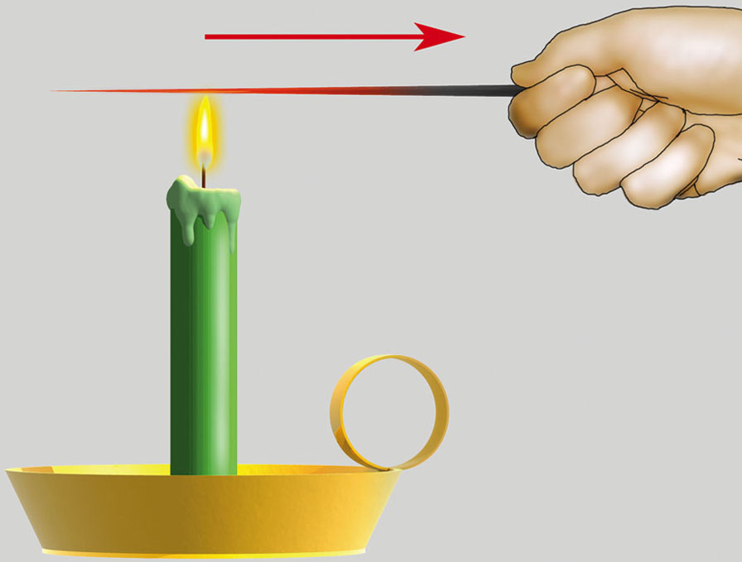
      - Visible light
      - Ultraviolet light

- Conductors and Insulators
  - _________________________ - material that transfers energy as heat _________________________
  - _________________________ - material that transfers energy _________________________
  - How is energy transferred?
    - Through particle collisions
    - The tighter that particles are packed into a substance (density) the more chance those particles will collide
    - When they collide, energy is transferred
- Specific Heat
  - Specific heat- how much _________________________it takes to change the _________________________of an object
    - Raise temperature of 1kg by 1K
  - Formula
    - Energy = specific heat x mass x temperature change
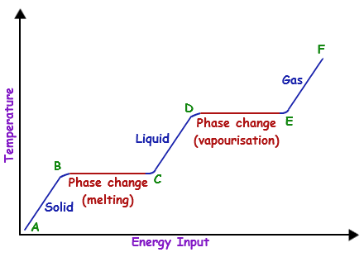
    - Energy = cmΔT
- Phase Diagram
  - When energy is added to a system in the form of heat:
    - The temperature will increase OR
    - There will be a phase (or state) change
  - It is one or the other, never at the same time
    - The temperature does not increase during a phase change, only before and after
  - We can graph this data to create a phase diagram
- Work
  - What is the definition of energy?
    - The ability to move matter
    - Another definition is: __________________________________________________
  - What is work?
    - When a _________________________applied on an object causes it to _________________________in the same direction
    - Work is also the __________________________________________________
      - From potential to kinetic, mechanical to kinetic, one object to another, etc
    - Work = force x distance or _________________________
  - Calculating work
    - Work = force x distance
      - Force is measured in Newtons
      - Distance is measured in meters
      - What is work measured in?
        - _________________________, which are the same as _________________________
- Power
  - _________________________ is the measure of how much _________________________ is done over a period of _________________________
    - Or, how much energy is transformed over time
  - Power = work / time or _________________________
  - Measured in _________________________
    - Takes 1W to do 1J of work in 1s
    - _________________________
- Machines
  - Machines don’t change the amount of work you do
    - They make the same amount of work easier to do
  - _________________________- make work _________________________ by:
    - Changing the size of the _________________________
    - Changing the _________________________ of the force
    - Both
- Mechanical Advantage
  - _________________________ - the __________________ between the output force and the _________________________
    - Mechanical advantage output force = input distance
  - input force output distance
  - Any machine that has a mechanical advantage more than _____ is reducing the amount of force you have to apply
- Waves
  - Wave- a _________________________ that carries _________________________ through _________________________ or _________________________
    - 2 types:
      - Electromagnetic: requires _________________________
      - _________________________: requires a medium
  - _________________________- the physical environment the wave travels through
    - Air, water, any type of matter
- Wave Movement
  - Transverse wave
    - Particles in the medium move perpendicularly to the direction the wave is traveling
      - Both mechanical and electromagnetic waves can move this way

  - Longitudinal wave
    - Particles of the medium vibrate parallel to the direction of wave motion
      - Only mechanical waves can move like this
- Mechanical Waves
  - _________________________- requires a medium, transfers energy through matter
    - Most waves are mechanical waves
- Electromagnetic Waves
  - Electromagnetic wave- changing _________________________ and _________________________ fields in space
    - Don’t require medium because they don’t move matter
    - This is why light and heat from the sun can travel to Earth
    - Travels through open space
  - Includes:
    - Visible light, not visible light, radio waves
- Energy and Waves
  - As wave travels, the energy _________________________
  - Same thing happens with sound
    - Standing right next to a speaker, sound appears louder
    - Standing further away it sounds softer
      - Because the further you get from the source of the energy (speaker), the more spread out the energy becomes
- Properties of Waves
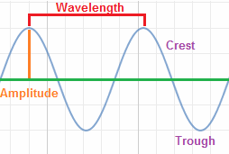
  - _________________________- the point in the wave where it is the furthest from the rest position
    - The _________________________ and _________________________ peaks
  - Wavelength (λ)- the _________________________ from __________________________________________________
  - Tell you information about energy
    - Higher amplitude = higher energy
    - Shorter wavelength = higher energy

  - _________________________- the _________________________ it takes for a complete wave (or cycle) to occur
    - How long it takes for the wave to get back to it’s starting point
    - What’s the difference between wavelength and period?
  - _________________________ - the number of waves produced over a set time
    - Measured in Hertz (Hz)
    - High frequency = high _________________________
  - Calculations
    - Frequency (f) = 1 / period (T) _________________________
    - Wave speed
      - speed = distance / time
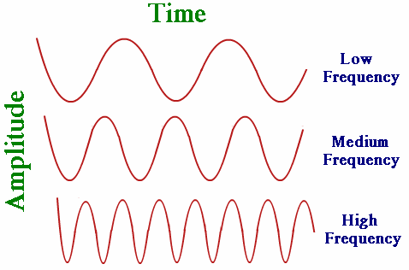
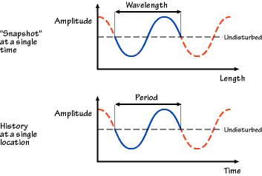
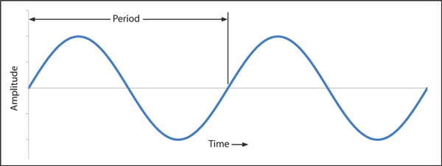
      - wave speed = wavelength / period v = λ / T

      - wave speed = frequency X wavelength v = f x λ

- Wave Interactions
  - Reflection
    - _________________________- when light, sound, or heat hits a surface that it cannot pass through
      - The bounding back of a wave when it meets a surface or boundary
  - Diffractions
    - Diffraction- a change in the _________________________ of a wave due to an obstacle or edge
    - The amount of diffraction depends on the wavelength and on the barrier
      - Larger wavelength = more diffraction
      - Larger opening = less diffraction
  - Refraction
    - _________________________- bending of a wave as it passes from one medium to another
      - Ex: a pencil in a glass of water
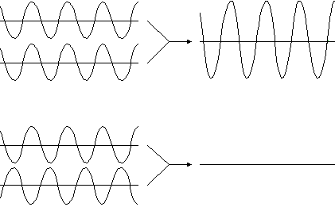
  - Interference
    - _________________________- the combination of two or more waves to create a new wave
    - Two types:
      - _________________________ interference- increases _________________________
      - _________________________ interference- _________________________ amplitude
- Speed of Waves
  - Sound travels at _________________________ or about 764 mph
    - Sound travels very fast, so you don’t usually notice the sound delay
  - Light travels at 299,792,458 m/s or about 6.7 x 10⁸ mph
    - Light travels so fast, you can’t notice a delay
- Speed of Sound
  - Sound travels faster through _________________________
    - More _________________________, more closely packed particles
    - Small vibrations are more quickly transferred to neighboring particles
  - Sound travels a bit slower through _________________________
    - Less dense, particles not as close together
  - Sound travels slowest through _________________________
    - Less dense
- Doppler Effect
  - _________________________- the observable change in the _________________________of a wave when the source or observer is _________________________

