Biology Unit 1 Notes Name:______________________________
- Skepticism-being doubtful about the truth of something
- What is science?

  - Testable
  - _______________ (disprovable)
  - Observable
  - Limited to _______________ ______________
  - Objective
  - Verifiable
  - Open to change
  - Skeptical
  - Made stronger by more evidence
  - A search for understanding

- Research
  - __________-reviewed journals are the most reliable resource
- Biology- the study of _______________
  - Many different fields and disciplines:

    - Cytology- the study of _____________
    - _______________- heredity
    - Evolution- ____________ over time
    - _____________- classification of living things
    - Anatomy- _______________
    - Physiology- function of parts
    - Microbiology- very small organisms
    - Zoology- animals
    - _______________- plants
    - Ecology- organisms and their ______________

- Characteristics of living things

    - Growth
    - Reproduction
    - Respond to stimuli
    - DNA
    - _______________
    - Homeostasis
    - Evolve
    - _______________

- Levels of organization (Green Reindeer Run Down My Hall Every Christmas)
  - _______________ is the smallest functional unit of life
  - Atoms molecules _______________ tissues organs _______________ _______________ _______________ community ecosystem biosphere
  - Population-
  - Community- populations that live together in a set area
  - Ecosystem-
  - Biosphere- all _______________ on earth
- Scientific method- a _____-step process to answer questions scientifically
  - Observation- use your _______________ to gather information
    - Data- evidence collected from _______________
  - _______________- logical interpretation based on observations and _______________
- Step 1-
- Step 2-
- Step 3- form a _______________
- Step 4- design an experiment
  - Must include:
    - Control group- factors that you _______________ change
    - _______________ group- change only what you are testing
    - Controlled variables- variables that are constant ______________________________
    - Manipulated/independent variable- the factor that you do change
    - _______________ /responding variable- what you measure, what is affected by the change
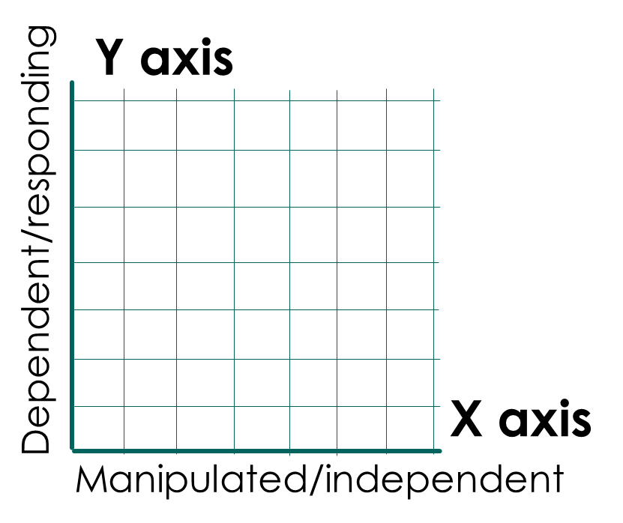
- Step 5-
  - Manipulated variable goes on the ___-axis
  - Dependent variable goes on the ___-axis
  - Line graph- shows _______________ data
  - _______________- good for comparing things
  - _______________- good for looking at percentages, showing parts of a whole
- Step 6- form conclusion(s)
  - Hypothesis cannot be proven
  - Should be supported by _______________ and _______________
_______________

_______________
_______________
_______________
- Step 7- Publish
  - Usually done in scientific _______________
- Theory vs. hypothesis
  - Theory- broad statement, links many _______________ together
- History of the scientific method
  - _______________ _______________- idea that living organisms came from non-living ones
  - Redi- put meat in covered and non-covered jars
    - Results:
  - Spallanzani- boiled broth in sealed and unsealed containers
    - Results:
  - Pasteur: boiled broth in curved flask left open, then broke neck of flask
    - Results:

- Tools of science
  - Microscopes
    - _______________ light- uses 2 lenses and light, good for looking at living specimens
      - Contrast:
      - Magnification:
    - Electron- uses electrons for greater magnification, can’t use on living things
    - Dissecting- low magnification, also called _______________
- Chemistry
  - Matter- anything with mass that takes up space, composed of _______________
    - Element- can’t be _______________ any further
  - Atomic structure
    - _______________- center of the atom
    - _______________- positively charged particles, located in nucleus
    - Neutrons- _______________ particles, located in nucleus
    - Electrons- _______________ charged particles, located _______________
  - _______________- formed by 2 or more atoms
    - Molecule- _______________ unit of a compound
  - Water- known as the universal _______________
    - Solution- made of solute and solvent, a _______________ mixture
      - Solute-
      - Solvent-
      - Saturated- when no more solute can be dissolved
      - _______________- when more solute can be dissolved
    - Water is a _______________ molecule, has a slight charge on both ends
      - Allows water to form _______________ bonds
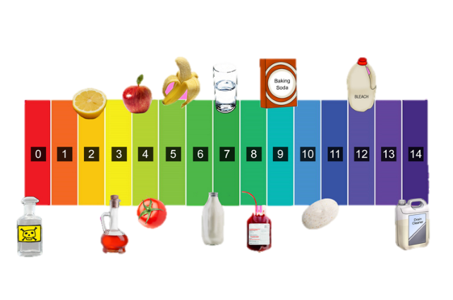
        - _______________- water bonds to itself with a hydrogen bond
        - Adhesion- water bonds to another polar molecule with a hydrogen bond
  - Acids and bases
    - Measured on a _______________ scale
      - Acids- low number
      - Bases- high number
      - Neutral- in the middle
- Macromolecules- _______________ compounds, make up all living things
  - Always contain the elements ___________ and ___________
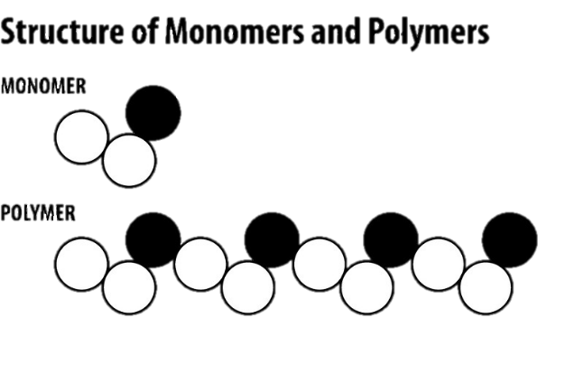
    - _______________- the backbone of life
  - Terminology
    - Monomer:
    - _______________- repeating monomers
    - Polymerization- process of combining _______________ to form _______________
  - 4 macromolecules
    - Carbohydrates- sugars, come from breads, fruits
      - Function: quick _______________
      - Building block: _______________
      - Form: polysaccharides
    - Lipids- commonly called _______________, come from oils, nuts, meats
      - Function: _________ _________, storage
        - Found in cell _______________
      - Building blocks: _______________
    - Proteins- comes from animal products and nuts
      - Functions:
        - _______________- speed up biological reactions
        - Building blocks of organisms
        - _______________ substances
        - Regulate cellular processes
        - Help fight disease
      - Building block: _______________
    - Nucleic acids- Blueprint of life
      - Function: carries _______________ _______________
      - Building blocks: _______________
        - Nucleotides: _______________, _______________, A, T, G, C, U
Organic compounds | Building blocks | Functions | Examples
Carbohydrates (sugars)
 | Fatty acids
Proteins
 | Nucleotides |  | DNA, RNA

- Chemical reaction- process of changing 1 set of elements or compounds into another by _______________ or _______________ bonds
  - Reactants:
  - _______________: elements or compounds produced by a reaction
  - Energy
    - Exergonic- _______________ energy
    - Endergonic- _______________ energy
- Enzymes- _______________ that act as biological catalysts
  - Catalyst- _______________ reactions
  - Speed up reaction by lowering _______________ energy
  - Use the __________ and __________ model
    - Substrate- compound going through the reaction, actually binds to the enzyme
    - _______________- area where substrate binds to the enzyme
  - Enzymes are
    - _______________, can be used again
    - Often have the ending -_______
    - Affected by extreme changes in _______________ and _______________

