**Slinky Wave Activity Name: __________________________________**

**Purpose:**

The purpose of the activity is to study the types of mechanical waves and their properties using a slinky.

**Materials:**

* You will need one of each of the following items for your group

### Slinky

### Meter stick

### Pencil

**Steps:**

* On the floor, stretch the slinky out between you and your partner, to a length of about four meters. (Do not over stretch)
* Send a single wave to your partner by rapidly lifting the slinky up and quickly returning it back to the ground.
  + What type of wave have you created? _______________________________
  + What happened to the wave when it reached your partner’s end? ______________________________________
* Move one end of the slinky side-to-side keeping it on the floor.
  + What type of wave have you created? _______________________________
  + What happens as you vary the rate at which your hand moves back and forth? ______________________________
* Next create a series of waves by moving your hand towards and away from your partner.
  + What type of wave have you created? _______________________________

**Questions:**

1. What is a wave?
2. Label the diagrams below with the appropriate wave type.

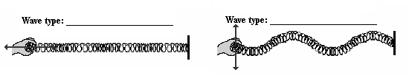

1. Identify the parts of the wave below

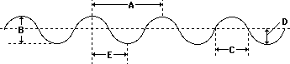 a.______________________

b.______________________

c.______________________

d.______________________

e.______________________

1. What happens to the frequency of the waves when you increase the rate of vibration (how fast your hand moved back and forth)?
2. What happens to the wavelength when you increase the rate of vibration (how fast your hand moved back and forth)?
3. What is the relationship between wavelength and frequency?