Unit 4 Density Worksheet NAME: _________________________________

- A student measures the mass of an 8 cm³ block of brown sugar to be 12.9 g. What is the density of the brown sugar?

- A chef fills a 50 mL container with 43.5 g of cooking oil. What is the density of the oil?

- Calculate the mass of a liquid with a density of 2.5 g/mL and a volume of 15 mL.

- Calculate the volume of a liquid with a density of 5.45 g/mL and a mass of 65 g.

- A machine shop worker records the mass of an aluminum cube as 176 g. If one side of the cube measures 4 cm, what is the density of the aluminum?

- A teacher performing a demonstration finds that a piece of cork displaces 23.5 mL of water. The piece of cork has a mass of 5.7 g. What is the density of the cork?

- A carver begins work on the following block of granite that weighs 2700 g. What is the density of the granite?

20
cm

10
cm

5 cm

- A piece of PVC plumbing pipe displaces 60 mL when placed into a container of water. If the pipe has a mass of 78 g, what is the density of PVC?

- A solid magnesium flare has a mass of 1300 g and a volume of 743 cm³. What is the density of the magnesium?

- A graduated cylinder has a mass of 50 g when empty. When 30 mL of water is added, the graduated cylinder has a mass of 120 g. If a rock is added to the graduated cylinder, the water level rises to 75 mL and the total mass is now 250 g. What is the density of the rock?

- A student performs an experiment with three unknown fluids and obtains the following measurements:
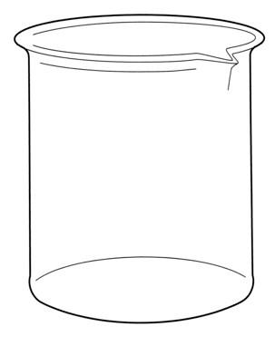
Fluid A: m = 2060 g, V = 2000 mL
Fluid B: m = 672 g, V = 850 mL
Fluid C: m = 990 g, V = 1100 mL

Draw how the fluids would be layered if they were combined in a beaker.

- Use your density skills to find the identity of the following mystery objects.

 | Table of Densities
Solids | Density g/cm³ | Solids | Density g/cm³
Marble | 2.56 | Copper | 8.92
Quartz | 2.64 | Gold | 19.32
Diamond | 3.52 | Platinum | 21.4
You think you have found a diamond. Its mass is 5.28 g and its volume is 2 cm3.

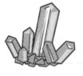
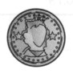
While digging in the backyard, you find an old coin. Its mass is 26.76 g and its volume is 3cm³.

What is the coin made of? |  |  |  | What did you find?

You find a ring with a mass of | There is a block on your desk that
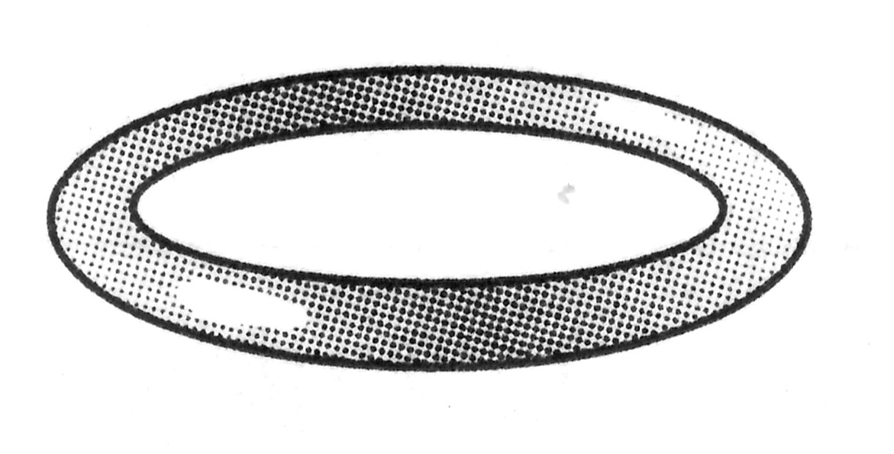
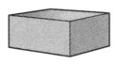
107 g. You fill a graduated cylinder acts as a paperweight. Its up with 10 mL of water and put the measurements are 3 cm by 4 cm by ring into the cylinder. The water 6 cm. The block has a mass of
rises up to the 15 mL mark.  What is the ring made of? |  | 184.32 g.  What is the block made of?

