**CIRCUIT DIAGRAM WORKSHEET**

**PART 1** - Convert the following descriptions to schematic circuit diagrams.

1.

Draw a circuit diagram containing

two batteries, one light, and

one switch, all connected in series.

2.

Draw a circuit diagram showing one battery and

two lamps, all

connected in series.

3.

Draw a circuit diagram containing

one battery and two lamps

connected in parallel.

4.

Draw a circuit diagram of a

resistor and a lamp connected in

parallel to a battery, with a switch that would only turn off the lamp.

**PART**

**2**

-

Convert the following

pictorials

to schematic circuit

diagrams AND

w

rite descriptions for each

pictorial.

5

.

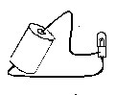

6

.

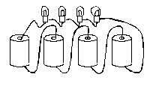

7

.

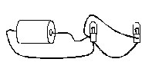

8

.

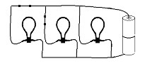

9

.

10

.

